1. **Docker Registry**:
   1. 
   2. Contains a lot of repositories and a lot of different versions of different applications.
   3. **Two types**:
      1. **Public Registry**:
      2. **Private Registry**:
2. 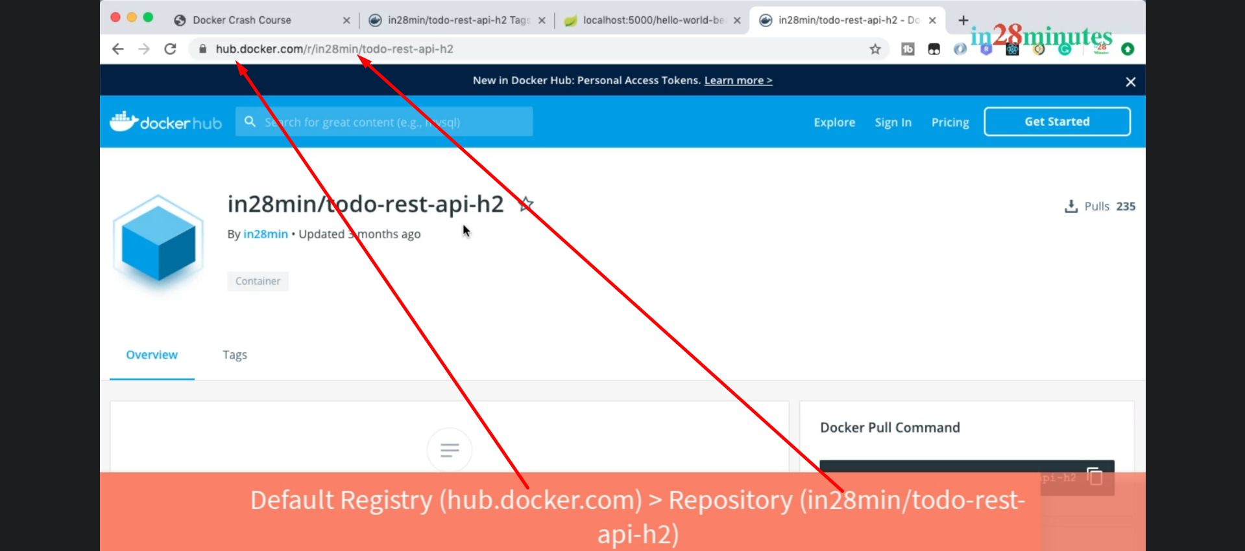
3. 
4. 
5. 
   1. Any container is part of **Bridge Network**.
6. 